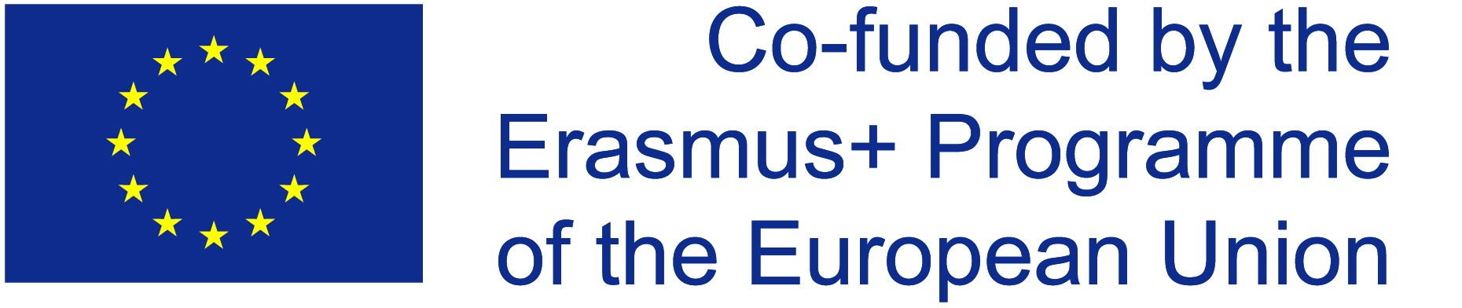
print form

Application Form 2019 – Media Arts Cultures (MediaAC)
Early Admission to the Media Arts Cultures Programme, and for participation with an Erasmus+ Scholarship.

Please fill in the form using Adobe Reader X, print it, then sign and date it by hand. Afterwards scan the paper and use for electronic application in PDF format. Application deadline for early admission and Erasmus+ scholarship for intake 2019 is January 6th, 2019.
More information: www.mediaartscultures.eu

Surname | Click or tap here to enter text.
First Name | Click or tap here to enter text.
Gender | Click or tap here to enter text.
Date of Birth (dd/mm/yyyy) | Click or tap here to enter text.
Place of Birth (City/Country) | Click or tap here to enter text.
Nationality (as in passport) | Click or tap here to enter text.
2nd Nationality (if applicable) | Click or tap here to enter text.
Email Address | Click or tap here to enter text.
Location of residence at time of application (Country and City) | Click or tap here to enter text.
Distance of Location of Residency to Krems, Lower Austria, Austria | Click or tap here to enter text.  in kilometers, to calculate use  http://ec.europa.eu/programmes/erasmus-plus/tools/distance_en.htm
I am eligible to apply for an Erasmus+/Erasmus Mundus scholarship |  | ☐ yes  ☐ no
I am eligible to apply to become an Erasmus+ /Erasmus Mundus scholarship holder from |  | ☐ Programme Country  ☐ Partner Country
12-month rule: In the period from 01 March 2014 to 15 February 2019, have you been a resident or have carried out your main activities (studies/training/work) for more than a total of 12 months in any of the Erasmus+ Programme Countries (28 EU members states, Iceland, Liechtenstein, Norway, FYR of Macedonia and/or Turkey)? |  | ☐ yes  ☐ no  If yes, specify where (all countries) and how long (in months)  Click or tap here to enter text.
If not granted an Erasmus+/Erasmus Mundus scholarship, I apply as self-funded / external-funded student |  | ☐ yes  ☐ no

Media Arts Cultures (MediaAC) - Application Form 2019 (page 2)
Early Admission to the Media Arts Cultures Programme, and for participation with an Erasmus+ Scholarship.

First university degree, defined as degree of at least three years in duration (in most cases a Bachelor degree).
If you hold more than one bachelor, please choose one. Other degrees can be noted below.

Subject | Click or tap here to enter text.
Type of Degree (e.g. Bachelor of Art) | Click or tap here to enter text.
University (Name in English) | Click or tap here to enter text.
University Country and Address | Click or tap here to enter text.
Other University degree(s), please state type of degree (e.g. Master of Science), subject, university and country
Other Degree (if applicable) | Click or tap here to enter text.
Other Degree (if applicable) | Click or tap here to enter text.
Do you require additional support due to special needs?  Explanation: "Special needs" means in this context e.g. physical disabilities. It does NOT relate to e.g. an applicant's family situation or to the fact that an applicant has a financially difficult background. You are asked for this information so that the MediaAC consortium may assist you in the best possible way. Like all your personal data, the information you provide on this issue is protected and it will in no way affect the chances of your application. |  | ☐ yes  ☐ no

Declaration of Honour
I, the undersigned, hereby declare that I have read all application instructions on www.mediaartscultures.eu and that the information I have provided is true and complete. I understand that for the purpose of student selection my application documents will be made accessible to MediaAC Consortium Partners and to reviewers appointed by the Consortium. I further understand that any misrepresentation in my application documents may be a cause for cancellation of my admission to the MediaAC Programme.

I accept that submission of this application in no way guarantees my right to participate in the MediaAC programme. I understand that students who have already obtained an EMJMD scholarship or an Erasmus Mundus Master Course / Joint Doctorate scholarship are not eligible to apply for an additional scholarship under the EMJMD action. I also understand that EMJMD scholarship holders cannot benefit from another EU funded scholarship or mobility schemes to attend the same EMJMD course and for this entire period of the course. I am aware that I can apply for an EMJMD scholarship to any of the Erasmus+ Erasmus Mundus courses of my choice, but am limited to a maximum of three different joint programs per academic year.

I understand that my personal data is collected and used in accordance with the Regulation (EU) 2016/679 and that I am entitled to obtain information on the storage of my personal data and may request appropriate limitation of its use.

If selected (proposed for a scholarship/fellowship, put on the reserve list or admitted a self-paying basis) my data is used for the purposes of evaluating the programmes, efficiently manage the projects, and producing statistics. Data could be made available to the EACEA, the European Commission, the European External Action Service staff, as well as to other stakeholders of the Erasmus+ programme, such as Erasmus+ National Agencies, National Erasmus+ Offices and the Erasmus Mundus Student and Alumni Association. Under restrictable conditions, my name and nationality may be published as part of the list of selected candidates on the MediaAC website, pictures taken of me during the programme may be used for dissemination activities for MediaAC and my contact details may be communicated to other students and alumni of MediaAC.

Surname, First Name | Click or tap here to enter text.
Click or tap here to enter text.
Date (dd/mm/yyyy) | Signature by hand (as in passport)

